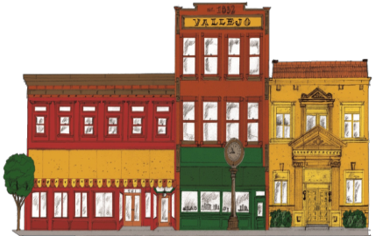
Promoting a cleaner, friendlier downtown Vallejo August 2013
Downtown Vallejo
Central Core Restoration Corporation

Central Core Restoration Corporation

Changes to CCRC Board
Elections: Thirteen candidates applied for a seat on the board at the July 11 meeting, including property owners, representatives, downtown business owners and concerned citizens. The following slate of directors was recommended by the nominating committee and voted in.

Jim Barcewski John Dooley
David Fischer Phil Elfstrom
Ken Ingersoll Buck Kamphausen
Bob Lando Robert Litwin
Fred Sessler Janet Sylvain

Appointments: CCRC has created a dedicated position for city representation on our board. We welcome Ms. Annette Taylor of Economic Development as a CCRC board director, with thanks for her ongoing contributions to CCRC and to Vallejo. Glad to have you on board, Annette!

Resignations: Board Member Dennis Brinson has resigned from CCRC after 13 years of dedicated service to the board and the downtown area. Mr. Brinson has been a committed and determined force for improvement in the downtown, and his efforts yielded real and significant change.

Past President Janet Sylvain said, “CCRC faced a lot of challenges during the time he served, and the Downtown District benefited each year from the projects he led and/or worked on.” The results of his initiatives helped to reduce loitering and curtail illegal dumping in downtown alleys. He spearheaded street improvement projects as well and zoning and ordinance changes that benefited property owners.
It is with deep gratitude that CCRC acknowledges Mr. Brinson’s community contributions. He will be missed!

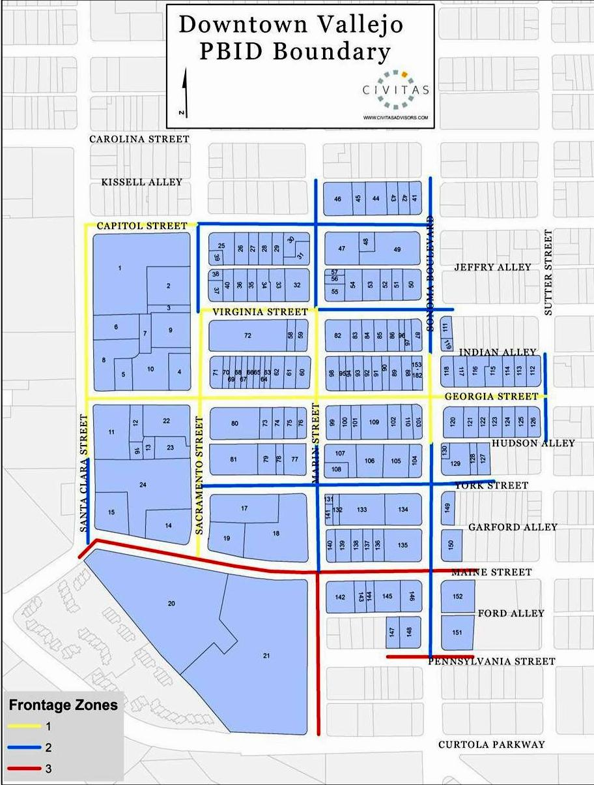

Community Resources & Partners

Black Talon Security
Dispatch 707-975-2166
Security is provided in the downtown 5 days a week, 10-6.
Officers Leo Osias, Michael George, Will Withers and Rony Banaria.

Neighborhood Law Program 707-648-4146
As part of a two year pilot program, NLP lawyers Eli Flushman and Ryan Griffiths work with the Vallejo Police Department, Code Enforcement Division and other departments, to abate the City's most unfavorable nuisances and improve the quality of life in Vallejo.

City of Vallejo Website
www.ci.vallejo.ca.us
A great and accessible resource where you can sign up to receive city updates, access the city calendar, and participate in Open City Hall, an online forum for civic engagement.

Vallejo Main Street 707-315-5282
vallejomainstreet.org
Community Partner in Downtown Development
Gregg Goins, President

Welcome to CCRC
Welcome to the current issue of CCRC’s Property and Business Improvement District (PBID) newsletter. This newsletter is designed to provide downtown property owners, business owners and other interested persons with information about activities conducted by the CCRC, as well as developments involving the downtown. To join our mailing list, please send your email address to ccrcvallejo@gmail.com or sign up through our new website.

List Your Property
We will post your commercial listings to increase your leasing and purchase opportunities. This free service is available to all stakeholders. Email ccrcvallejo@gmail.com and we will get your listing online! Please include up to 4 photos of your property and up to 300 characters of text describing your property.

Force for Good!
Many of you are familiar with the bicycle officers that patrol our downtown. Officers Michael George, Will Withers, Leo Osias and Rony Banaria are the dedicated Black Talon Security officers that patrol daily to keep the peace in the downtown district. Their daily presence is invaluable in a city where our police force is understaffed and often unable to actively address issues particular to the Downtown District. They are a great resource in reinforcing CCRC’s efforts to efficiently address issues involving graffiti, illegal dumping, nuisance issues and code enforcement in collaboration with city agencies. Additionally they work closely with Vallejo Police Department to support the management of the downtown. Board Member Jim Barcewski is the new committee chair over security and can be reached at 707-644-8887 if you have any questions regarding security. Black Talon dispatch is 707.975.2166.
Your CCRC Board
Pres. Buck Kamphausen, Skyview Memorial
VP Phil Elfstrom, Evergreen Trust
Secretary Bob Lando, Vallejo Maine Partners
Treasurer Robert Litwin, Bay Property
Jim Barcewski, Georgia Street Plaza
John Dooley, Member-at-large
David Fischer, Downtown Property Owner
Ken Ingersoll, Gracie’s Barbeque
Fred Sessler, Sessler Realty
Janet Sylvain, Pieced On Earth
Annette Taylor, City of Vallejo

We are here for you, the stakeholders of CCRC. Please let us know of your concerns and ideas for the improvement of our downtown!

Some Who, What and Why

CCRC: Central Core Restoration Corporation

Established: 2001, in response to the particular need s of our downtown historic and commercial district which was in need of more resources than could be provided by city agencies and the police department.

How are we funded? We are funded by tax assessments which were approved at the time of establishment by downtown property owners.

Purpose: Our purpose is to revitalize and promote the economic well-being of Downtown Vallejo through the proactive utilization of our management district, the creation of Downtown Vallejo public-private partnerships, and related activities.

Inside This Issue

1 | Elections and Changes to the Board
2 | CCRC FAQs
3 | Calendar of Events and Community Resources
4 | Contact Information

Board Membership
CCRC accepts applications for committed people to serve on our board as directors or alternate directors. Our 11-person board is made up of property owners or their representatives, business owners, and at-large members within our district boundaries (see map p. 3).
If you meet the criteria above and are interested in working to help the downtown develop, please contact our office at 707.557.6762 for application information, or print out the downloadable form at downtownvallejo.com and return to Erin Bakke, Executive Coordinator, 301 Georgia St., Suite 290, Vallejo CA 94590.

CCRC Mission Statement
Our mission is to revitalize Historic Old Town Vallejo as the Main Street of commercial and cultural activity that promotes shopping, working, dining, and living in a secure and progressive environment.

Around Downtown:
Calendar of Events

Gracie’s friday night summer music series
Every Friday, June through September
Gracie's BBQ, 1801 Sonoma Blvd
(707) 552-2254

Farmer’s Market
Saturdays from 9-1
300-400 Block of Georgia St
Pacific Coast Farmers Market (925) 825-9090

Empress Wednesday Night Ramble
Wednesdays from 7-10
Empress Theatre, 330 Virginia St
Tickets $7 in Advance/ $9 Door
Blues, Americana, roots, Rock, R &B
(707) 552-2400 or EmpressTheatre.org

Vallejo Admirals Baseball!
Check out their schedule at www.vallejoadmirals.com

CCRC Board of Directors Meetings
Your CCRC Board of Directors meets regularly to review PBID operations, plan future activities, accept reports from its contractors and to seek input from stakeholders and others. Meetings are usually held on the second Thursday of each month at 4:15 in the 2nd floor conference room at 301 Georgia Street. The meeting agendas are posted at this location and are also available at www.downtownvallejo.com.

Contact
Central Core Restoration Corporation (CCRC)
301 Georgia Street, Suite 290
Vallejo, CA 94590
(707) 557-6762
(707) 557-6040 Fax
CCRCVallejo@gmail.com

Erin Bakke, Executive Coordinator

