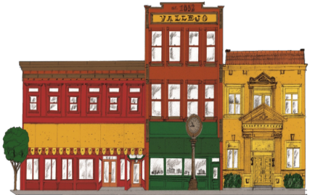
Promoting a cleaner, friendlier downtown Vallejo October 2013
Downtown Vallejo
Central Core Restoration Corporation

Central Core Restoration Corporation

Changes to CCRC Board
Elections: Thirteen candidates applied for a seat on the board at the July 11 meeting, including property owners, representatives, downtown business owners and concerned citizens. The following slate of directors was recommended by the nominating committee and voted in.

Jim Barcewski John Dooley
David Fischer Phil Elfstrom
Ken Ingersoll Buck Kamphausen
Bob Lando Robert Litwin
Fred Sessler Janet Sylvain

Appointments: CCRC has created a dedicated position for city representation on our board. We welcome Ms. Annette Taylor of Economic Development as a CCRC board director, with thanks for her ongoing contributions to CCRC and to Vallejo. Glad to have you on board, Annette!

Election: CCRC has created positions for Alternate Directors, and would like to welcome Mark Reed to the Board in that capacity.

Resignations: Board Member Dennis Brinson has resigned from CCRC after 13 years of dedicated service to the board and the downtown area. Mr. Brinson has been a committed and determined force for improvement in the downtown, and his efforts yielded real and significant change.
Past President Janet Sylvain said, “CCRC faced a lot of challenges during the time he served, and the Downtown District benefited each year from the projects he led and/or worked on.” The results of his initiatives helped to reduce loitering and curtail illegal dumping in downtown alleys, to name but a few results of his efforts. It is with deep gratitude that CCRC acknowledges Mr. Brinson’s contributions. He will be missed!

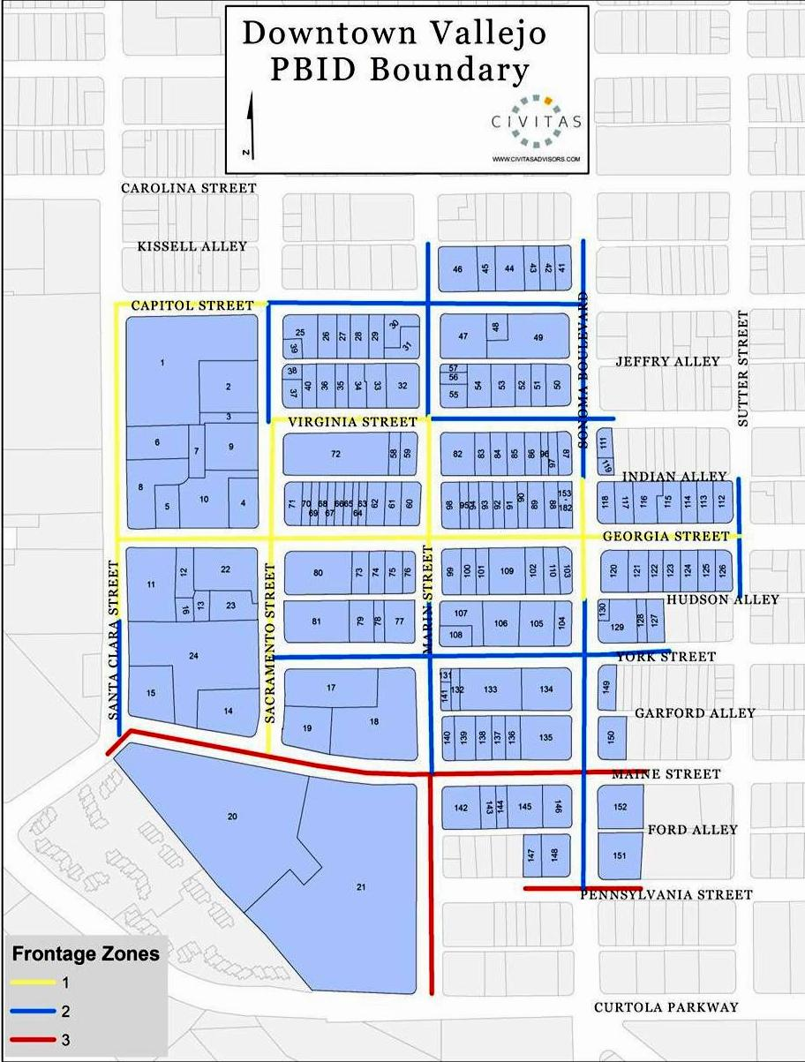

Community Resources & Partners
Black Talon Security Dispatch 707-975-2166
Security is provided in the downtown 5 days a week, 10-6.
Neighborhood Law Program 707-648-4146
As part of a two year pilot program, NLP lawyers Eli Flushman and Ryan Griffiths work with the Vallejo Police Department, Code Enforcement Division and other departments, to abate the City's most unfavorable nuisances and improve the quality of life in Vallejo.
City of Vallejo
www.ci.vallejo.ca.us 707-648-4527
A great and accessible website with city updates, city calendar, and Open City Hall, an online forum for civic engagement. City Council meetings are held the 2nd and 4th Tuesdays of the month at City Hall, 555 Santa Clara St.
Vallejo Main Street
www.vallejomainstreet.org 707-315-5282
Community Partner in Downtown Development
Gregg Goins, President
Fighting Back Partnership 707-553-7345
A non-profit collaboration that partners with business, residents, and government to improve neighborhoods, strengthen families, and support youth development creating a safe, healthy and thriving community.
Next Door Neighborhood www.nextdoor.com
An online meeting place to help build stronger, safer neighborhoods.
Jfjkdf

Welcome!
Welcome to the current issue of CCRC’s Property and Business Improvement District (PBID) newsletter. This newsletter is designed to provide downtown property owners, business owners and other interested persons with information about activities conducted by the CCRC, as well as developments involving the downtown.
To join our mailing list, please send your email address to ccrcvallejo@gmail.com or sign up through our website at downtownvallejo.com.

List Your Property
We will post your commercial listings to increase your leasing and purchase opportunities. This free service is available to all stakeholders.
Email ccrcvallejo@gmail.com and we will get your listing online! Please include up to 4 photos of your property and up to 300 characters of text describing your property.

Force for Good!
Many of you are familiar with the bicycle officers that patrol our downtown. Officers Will Withers, Michael George, Leo Osias and Rony Banaria are the dedicated Black Talon Security officers keeping the peace in the downtown district. Their daily (M-F) presence is invaluable in a city where our police force is understaffed and often unable to actively address issues within the Downtown District. They are a great resource in reinforcing CCRC’s efforts to efficiently address issues involving graffiti, illegal dumping, nuisance issues and code enforcement in collaboration with city agencies. Additionally, they work closely with Vallejo PD to improve downtown. Board Member Jim Barcewski is the new committee chair over security and can be reached at 707-644-8887 if you have any questions.
Black Talon dispatch is 707.975.2166.

Your CCRC Board
Pres. Buck Kamphausen, Skyview Memorial
VP Phil Elfstrom, Evergreen Trust
Secretary Bob Lando, Vallejo Maine Partners
Treasurer Robert Litwin, Bay Property
Jim Barcewski, Georgia Street Plaza
John Dooley, Member-at-large
David Fischer, Downtown Property Owner
Ken Ingersoll, Gracie’s Barbeque
Fred Sessler, Sessler Realty
Janet Sylvain, Pieced On Earth
Annette Taylor, City of Vallejo
Alternate Director Mark Reed, Townhouse

We are here for you, the stakeholders of CCRC. Please let us know of your concerns and ideas for the improvement of our downtown!

Some Who, What and Why

CCRC: Central Core Restoration Corporation
Established: 2001, in response to the particular needs of our downtown historic and commercial district which was in need of more resources than could be provided by city agencies and the police department.
How are we funded? We are funded by tax assessments which were approved at the time of establishment by downtown property owners.
Purpose: Our purpose is to revitalize and promote the economic well-being of Downtown Vallejo through the proactive utilization of our management district, the creation of Downtown Vallejo public-private partnerships, and related activities.

Inside This Issue

1 Elections and Changes to the Board
2 CCRC FAQs, Security
3 Calendar of Events, PBID Map, and Community Resources
4 Business, City News, Things to Do…

Board Membership
CCRC continually accepts applications for committed people to serve on our board as directors or alternate directors. Our 11-person board is made up of property owners or their representatives, business owners, and at-large members within our district boundaries (map p. 3).
If you meet the criteria above and are interested in working to help the downtown develop, please contact our office at 707.557.6762 for application information, or print out the downloadable form at downtownvallejo.com and return to Erin Bakke, Executive Coordinator, 301 Georgia St., Suite 290, Vallejo CA 94590.

CCRC Mission Statement
Our mission is to revitalize Historic Old Town Vallejo as the Main Street of commercial and cultural activity that promotes shopping, working, dining, and living in a secure and progressive environment.

Around Downtown:
Calendar of Events
Farmer’s Market
Saturdays from 9-1
300-400 Block of Georgia St
Pacific Coast Farmers Market (925) 825-9090
Empress Wednesday Night Ramble
Every Wednesday from 7-10
Empress Theatre, 330 Virginia St
Tickets $7 in Advance/ $9 Door
Blues, Americana, roots, Rock, R &B
(707) 552-2400 or EmpressTheatre.org
Vallejo Art Windows
Ongoing through Oct 2014
Downtown
Maps Available at Vallejoartwindows.com and Ferry Bldg
Vallejo Open Studios
Nov 9 and 10
Citywide, including downtown
Vallejoopenstudios.com for map
Free
Mad Hatter Holiday Festival
Saturday, DEC 7
Historic Downtown Vallejo, Georgia St. to the Waterfront
Parade 4:30, Annual Tree Lighting 7 pm
www.facebook.com/MadHatterHolidayVallejo

CCRC Meetings
Your CCRC Board of Directors meets regularly to review PBID operations, plan future activities, accept reports from its contractors and to seek input from stakeholders and others. Meetings are usually held on the second Thursday of each month at 4:15 in the 2nd floor conference room at 301 Georgia Street. The meeting agendas are posted at this location and are also available at www.downtownvallejo.com.
The public is welcome to attend.

Contact CCRC
Central Core Restoration Corporation
301 Georgia Street, Suite 290
Vallejo, CA 94590
(707)557-6762/fax (707)557-6040
ccrcvallejo@gmail.com
Erin Bakke, Executive Coordinator
UpBeat Downtown

City Hall
We welcome interim Chief Building Official Glen Martinez, who replaces predecessor Gary West. He is proving to be accessible and easy to work with. He can be reached at (707)648-4387.

Also new to the city is Mark Sawicki, Vallejo’s new Community and Economic Development Director, replacing Ursula Luna-Reynosa who left the city in March. He can be reached at (707)648-4326.
Street Improvements Planned
Phase 3 of federal grant monies is moving forward for street improvements in the downtown, with Georgia Street slated for the next round of improvements.
Library Renovations
The library at 505 Santa Clara has reopened after renovations, and has moved the children’s section up to the second (main) floor.
Post Office
The City continues to plan to relocate the post office on Santa Clara St. in order to build phase 2 of the parking structure, with a proposed hotel on top.

Business Developments
Subway is moving forward with its new location at Sonoma and Virginia Streets, and it will be our first national chain restaurant to come downtown. They anticipate opening in mid-November.
Mare Island Brewery Tasting Room
The lease at the Ferry building at the waterfront has been approved, in large part due to a new ordinance that allows tasting rooms in the downtown. Check out their website at mareislandbrewingco.com, and watch their progress!

More Downtown
Stuff to Do

The Hub at the Odd Fellows Hall, 342 Georgia, offers sewing, watercolor painting, home brewing and writing workshops as part of their new format as a community art center. For a schedule of classes drop by, or check out www.luludeuxmillinery.com/workshops.
The Townhouse at 401 Georgia hosts Open Mic night every Wednesday, 8 pm to midnight. Visit their Facebook page for more info or call (707) 553-9190.
Opus in Oils at 623 Marin offers children’s and senior’s art classes. Call (707)656-3150 for more info.
Mini Art at 620 Marin offers acrylic painting classes Thursday nights, beginning Nov 8. Call Jeff Snell at (510)220-3692 for details.
“Never doubt that a small group of thoughtful, committed, citizens can change the world. Indeed, it is the only thing that ever has.” Margaret Mead

Volunteer Opportunities
Empress Theatre is staffed solely by volunteers! If you’d like to be part of their fun-loving team, contact Lauren Nelson, Volunteer Coordinator at Staff@empresstheatre.org

JFK Library needs volunteers for its various programs. To learn more contact Muffy Walker, volunteer coordinator at 707-784-1506.

Saturday Farmer’s Market
CCRC and Pacific Coast Farmer’s Market Association work together closely to provide Vallejo with an ever-improving certified farmer’s market. We are embarking upon a new marketing campaign and are working to make the market even more family-friendly, and to improve and expand its quality and selection. If you are interested in becoming a vendor or have questions regarding the market, contact Regional Manager Greg Pursley at 925-771-2906 /gregpursley@pcfma.com, or Director John Silveira at 925-771-2903 / john@pcfma.com.

